LAMPIRAN
HASIL PENGUKURAN, DIAGRAM, ANALISIS DAN HASIL REDESAIN

Titik ukur | Standar kenyamanan | Waktu pengukuran
 |  | Pagi  (dalam celcius) |  |  | Siang  (dalam celcius) |  |  | Sore  (dalam celcius) |  |  | Malam  (dalam celcius)
1 | 22,8°C - 25,8°C | 26 | 26 | 25 | 29 | 30 | 30 | 28 | 29 | 28 | 26 | 27 | 27
2 |  | 27 | 25 | 25 | 30 | 31 | 31 | 28 | 29 | 29 | 27 | 28 | 28
3 |  | 27 | 26 | 26 | 29 | 29 | 31 | 29 | 28 | 28 | 27 | 28 | 28
4 |  | 26 | 27 | 26 | 29 | 29 | 31 | 29 | 28 | 29 | 26 | 27 | 26
5 |  | 27 | 27 | 27 | 29 | 31 | 30 | 30 | 30 | 29 | 28 | 27 | 28
6 |  | 26 | 26 | 25 | 30 | 29 | 29 | 30 | 30 | 30 | 28 | 27 | 27
7 |  | 25 | 25 | 26 | 30 | 31 | 30 | 29 | 28 | 30 | 27 | 26 | 26
8 |  | 26 | 25 | 27 | 31 | 30 | 31 | 29 | 28 | 30 | 28 | 27 | 26
9 |  | 26 | 26 | 27 | 31 | 30 | 31 | 28 | 29 | 29 | 28 | 27 | 27
10 |  | 27 | 27 | 26 | 30 | 31 | 30 | 28 | 29 | 28 | 25 | 26 | 25
11 |  | 27 | 26 | 27 | 29 | 29 | 29 | 29 | 28 | 28 | 25 | 26 | 25
12 |  | 26 | 26 | 27 | 30 | 31 | 30 | 30 | 30 | 31 | 26 | 25 | 26
13 |  | 27 | 26 | 27 | 29 | 29 | 29 | 30 | 30 | 31 | 26 | 28 | 27
14 |  | 27 | 25 | 25 | 29 | 30 | 31 | 29 | 28 | 31 | 26 | 26 | 28
15 |  | 27 | 27 | 26 | 30 | 31 | 30 | 28 | 29 | 28 | 25 | 26 | 25
16 |  | 27 | 26 | 27 | 29 | 29 | 29 | 29 | 28 | 28 | 25 | 26 | 25
Tabel 1. hasil pengukuran suhu

Tabel 2. hasil pengukuran pencahayaan
Titik ukur | Standar kenyamanan | Waktu pengukuran
 |  | Pagi  (dalam lux) |  |  | Siang  (dalam lux) |  |  | Sore  (dalam lux) |  |  | Malam  (dalam lux)
1 | >200 lux | 126 | 136 | 121 | 146 | 136 | 151 | 111 | 106 | 104 | 60 | 66 | 71
2 |  | 77 | 97 | 97 | 71 | 97 | 97 | 61 | 50 | 73 | 51 | 97 | 97
3 |  | 87 | 97 | 77 | 80 | 97 | 71 | 90 | 67 | 75 | 60 | 67 | 71
4 |  | 126 | 136 | 121 | 156 | 136 | 151 | 111 | 116 | 101 | 90 | 66 | 81
5 |  | 127 | 137 | 122 | 145 | 137 | 142 | 111 | 107 | 102 | 90 | 77 | 72
6 |  | 86 | 96 | 76 | 80 | 96 | 71 | 90 | 91 | 61 | 87 | 66 | 71
7 |  | 125 | 125 | 126 | 126 | 125 | 146 | 122 | 115 | 116 | 78 | 55 | 76
8 |  | 126 | 126 | 128 | 156 | 126 | 138 | 122 | 116 | 118 | 71 | 76 | 78
9 |  | 76 | 86 | 96 | 79 | 86 | 90 | 110 | 83 | 50 | 70 | 66 | 90
10 |  | 127 | 147 | 137 | 142 | 147 | 127 | 124 | 117 | 117 | 72 | 87 | 67
11 |  | 127 | 137 | 137 | 134 | 137 | 157 | 115 | 97 | 107 | 84 | 87 | 77
12 |  | 126 | 126 | 136 | 132 | 126 | 166 | 98 | 96 | 106 | 93 | 96 | 76
13 |  | 127 | 117 | 117 | 122 | 117 | 137 | 89 | 98 | 78 | 71 | 97 | 87
14 |  | 127 | 137 | 117 | 112 | 137 | 137 | 99 | 97 | 76 | 67 | 97 | 87
15 |  | 127 | 147 | 137 | 142 | 147 | 127 | 124 | 117 | 117 | 72 | 87 | 67
16 |  | 127 | 137 | 137 | 134 | 137 | 157 | 115 | 97 | 107 | 84 | 87 | 77
Tabel 3. hasil pengukuran tingkat kebisingan

Titik ukur | Standar kenyamanan | Waktu pengukuran
 |  | Pagi  (dalam dB) |  |  | Siang  (dalam dB) |  |  | Sore  (dalam dB) |  |  | Malam  (dalam dB)
1 | < 55 dB | 76.1 | 72.2 | 71.1 | 76.4 | 72.2 | 71.1 | 76.1 | 72.2 | 51.1 | 46.1 | 42.2 | 51.4
2 |  | 57.2 | 57.2 | 57.2 | 87.2 | 87.2 | 57.2 | 77.2 | 77.2 | 47.5 | 57.2 | 57.4 | 57.2
3 |  | 57.1 | 57.1 | 57.1 | 87.1 | 87.1 | 57.1 | 77.0 | 77.1 | 47.4 | 57.1 | 57.4 | 57.2
4 |  | 66.6 | 66.5 | 64.5 | 66.6 | 66.5 | 64.5 | 63.0 | 66.5 | 64.4 | 46.6 | 56.4 | 64.5
5 |  | 77.7 | 78.7 | 78.7 | 77.7 | 78.7 | 78.7 | 77.7 | 78.7 | 58.7 | 47.7 | 68.7 | 78.7
6 |  | 40.7 | 46.7 | 42.7 | 43.7 | 44.7 | 46.7 | 47.5 | 46.7 | 46.7 | 46.7 | 46.5 | 46.7
7 |  | 75.7 | 71.7 | 70.7 | 75.7 | 71.7 | 70.7 | 75.4 | 71.7 | 70.4 | 45.7 | 71.7 | 50.2
8 |  | 66.5 | 61.5 | 62.5 | 66.5 | 61.5 | 62.5 | 64.5 | 61.4 | 62.5 | 56.5 | 61.5 | 62.5
9 |  | 46.4 | 46.4 | 46.4 | 46.4 | 46.2 | 46.4 | 46.4 | 46.3 | 46.4 | 46.4 | 46.4 | 46.4
10 |  | 67.7 | 61.4 | 67.3 | 67.7 | 61.5 | 67.3 | 67.3 | 61.3 | 47.3 | 47.7 | 61.5 | 67.2
11 |  | 77.8 | 71.8 | 72.3 | 77.8 | 71.8 | 72.3 | 77.8 | 71.8 | 52.4 | 47.8 | 41.8 | 52.3
12 |  | 66.0 | 65.0 | 64.0 | 76.0 | 75.0 | 64.0 | 66.5 | 55.4 | 54.3 | 56.0 | 65.0 | 54.0
13 |  | 67.0 | 63.1 | 67.1 | 67.5 | 73.1 | 67.1 | 57.0 | 43.1 | 67.3 | 37.0 | 63.6 | 67.5
14 |  | 67.2 | 64.2 | 64.1 | 67.5 | 54.2 | 64.1 | 57.4 | 44.2 | 64.1 | 37.2 | 64.6 | 64.6
15 |  | 75.7 | 71.7 | 70.7 | 75.7 | 71.7 | 70.7 | 75.4 | 71.7 | 70.4 | 45.7 | 71.7 | 50.2
16 |  | 66.5 | 61.5 | 62.5 | 66.5 | 61.5 | 62.5 | 64.5 | 61.4 | 62.5 | 56.5 | 61.5 | 62.5

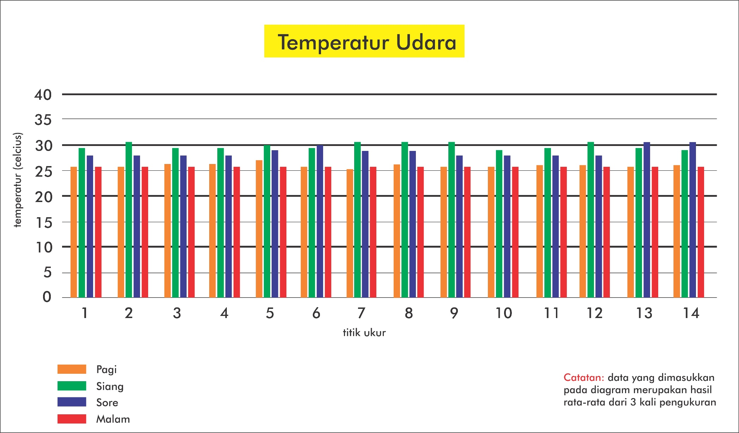
Gambar 1. Diagram hasil pengukuran suhu

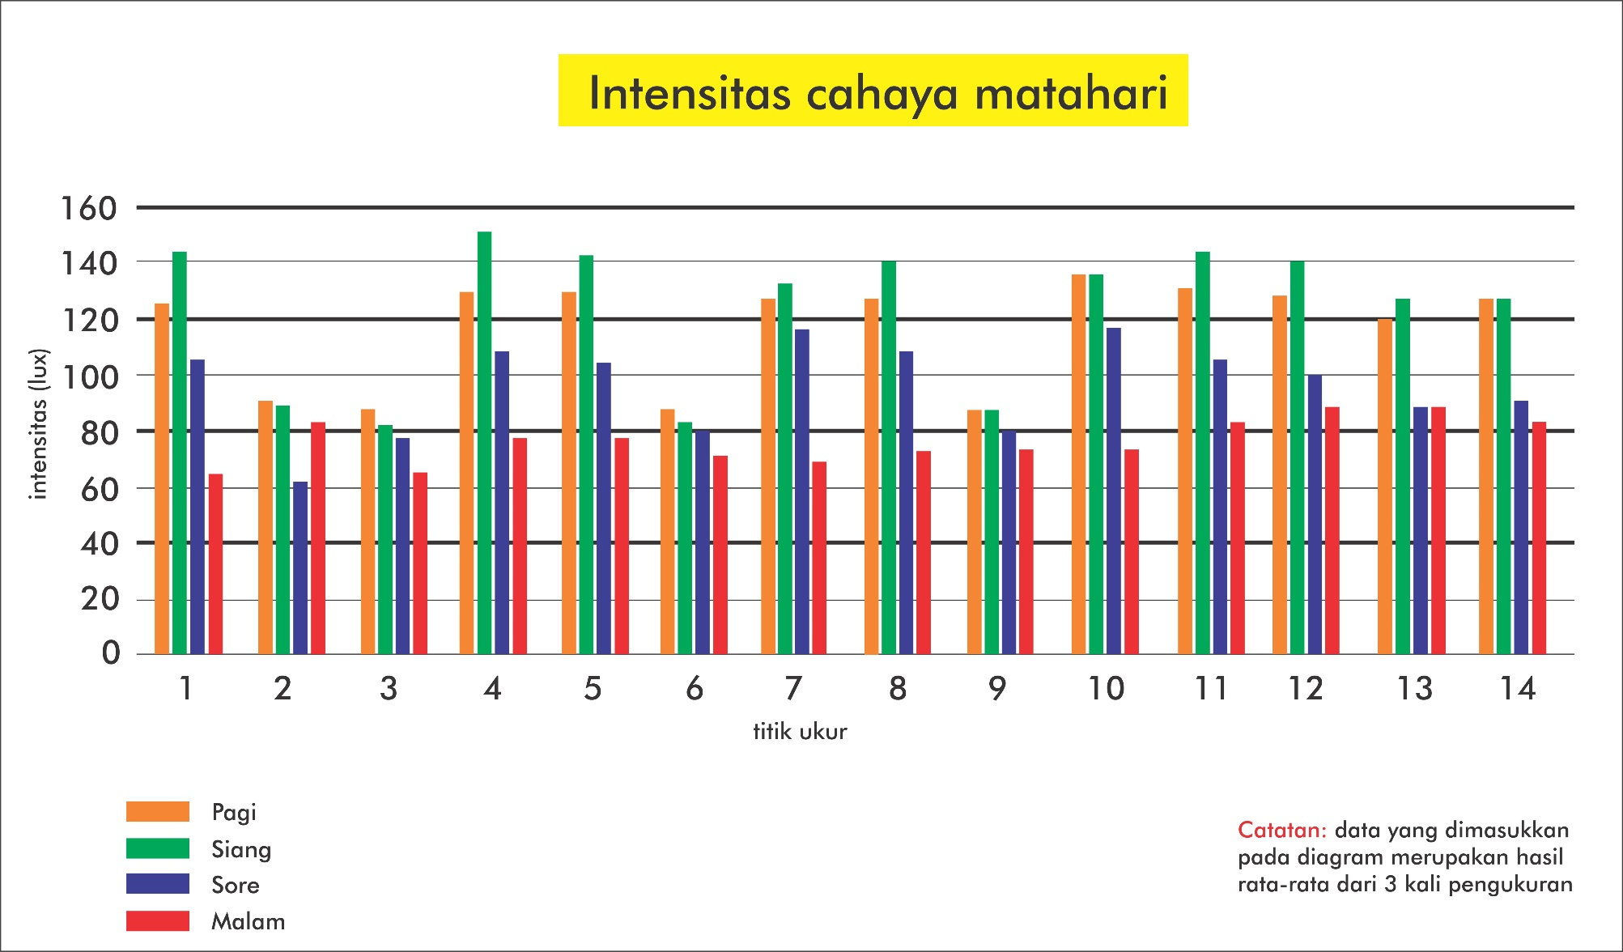
Gambar 2. Diagram hasil pengukuran pencahayaan

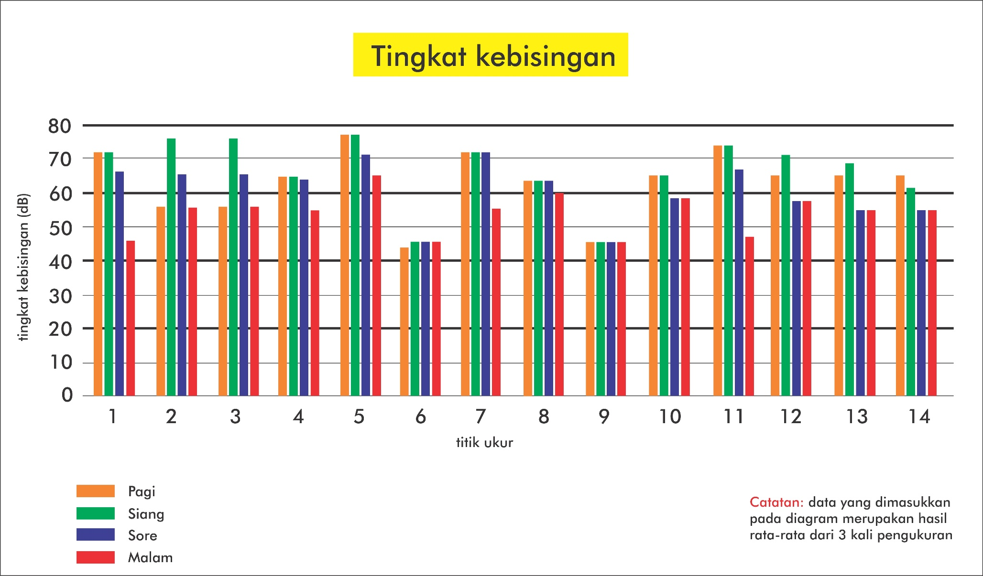
Gambar 3. Diagram hasil pengukuran tingkat kebisingan

ANALISIS DAN HASIL REDESAIN
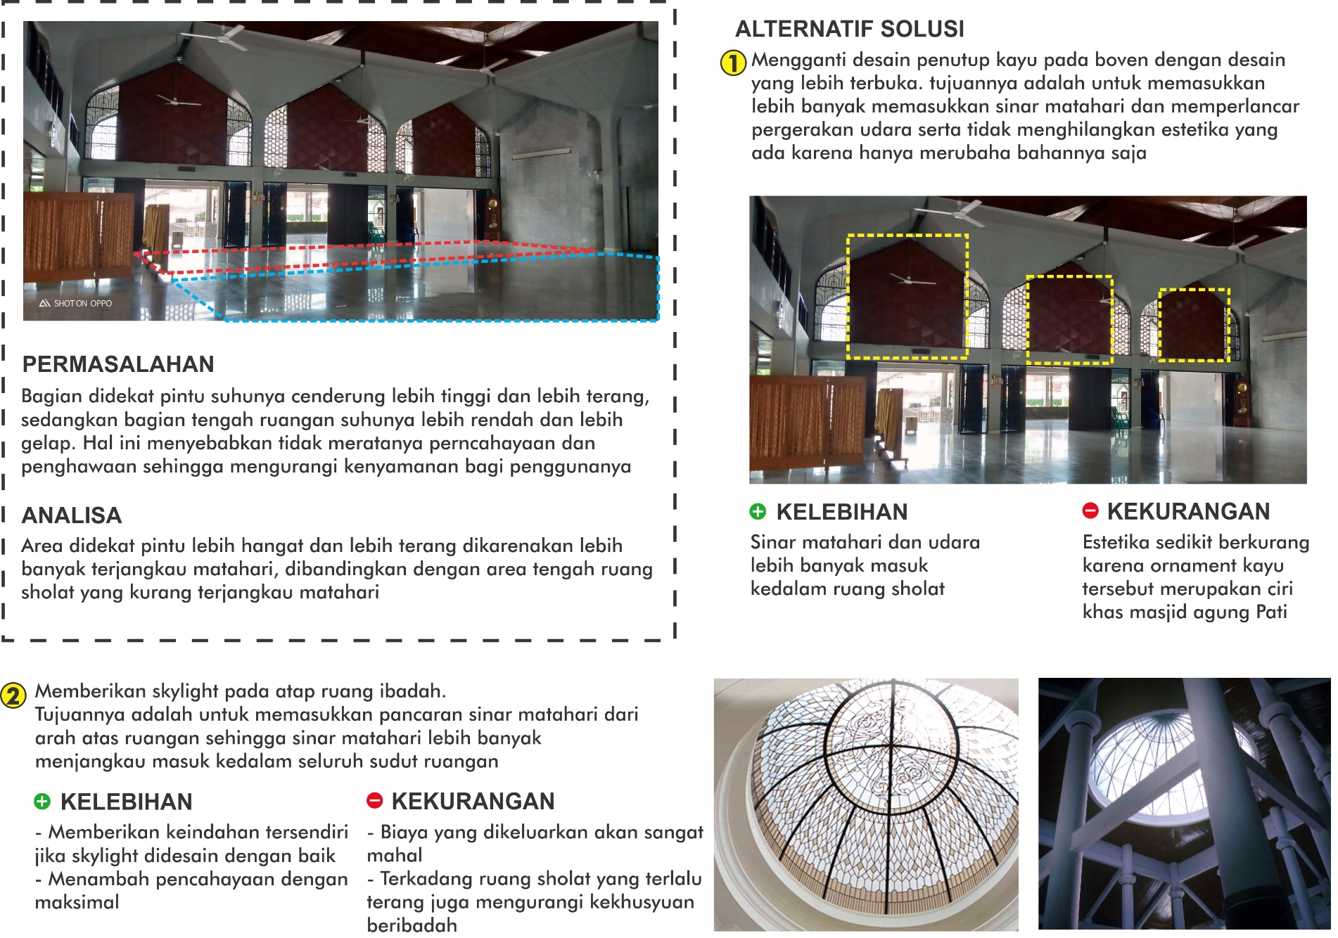

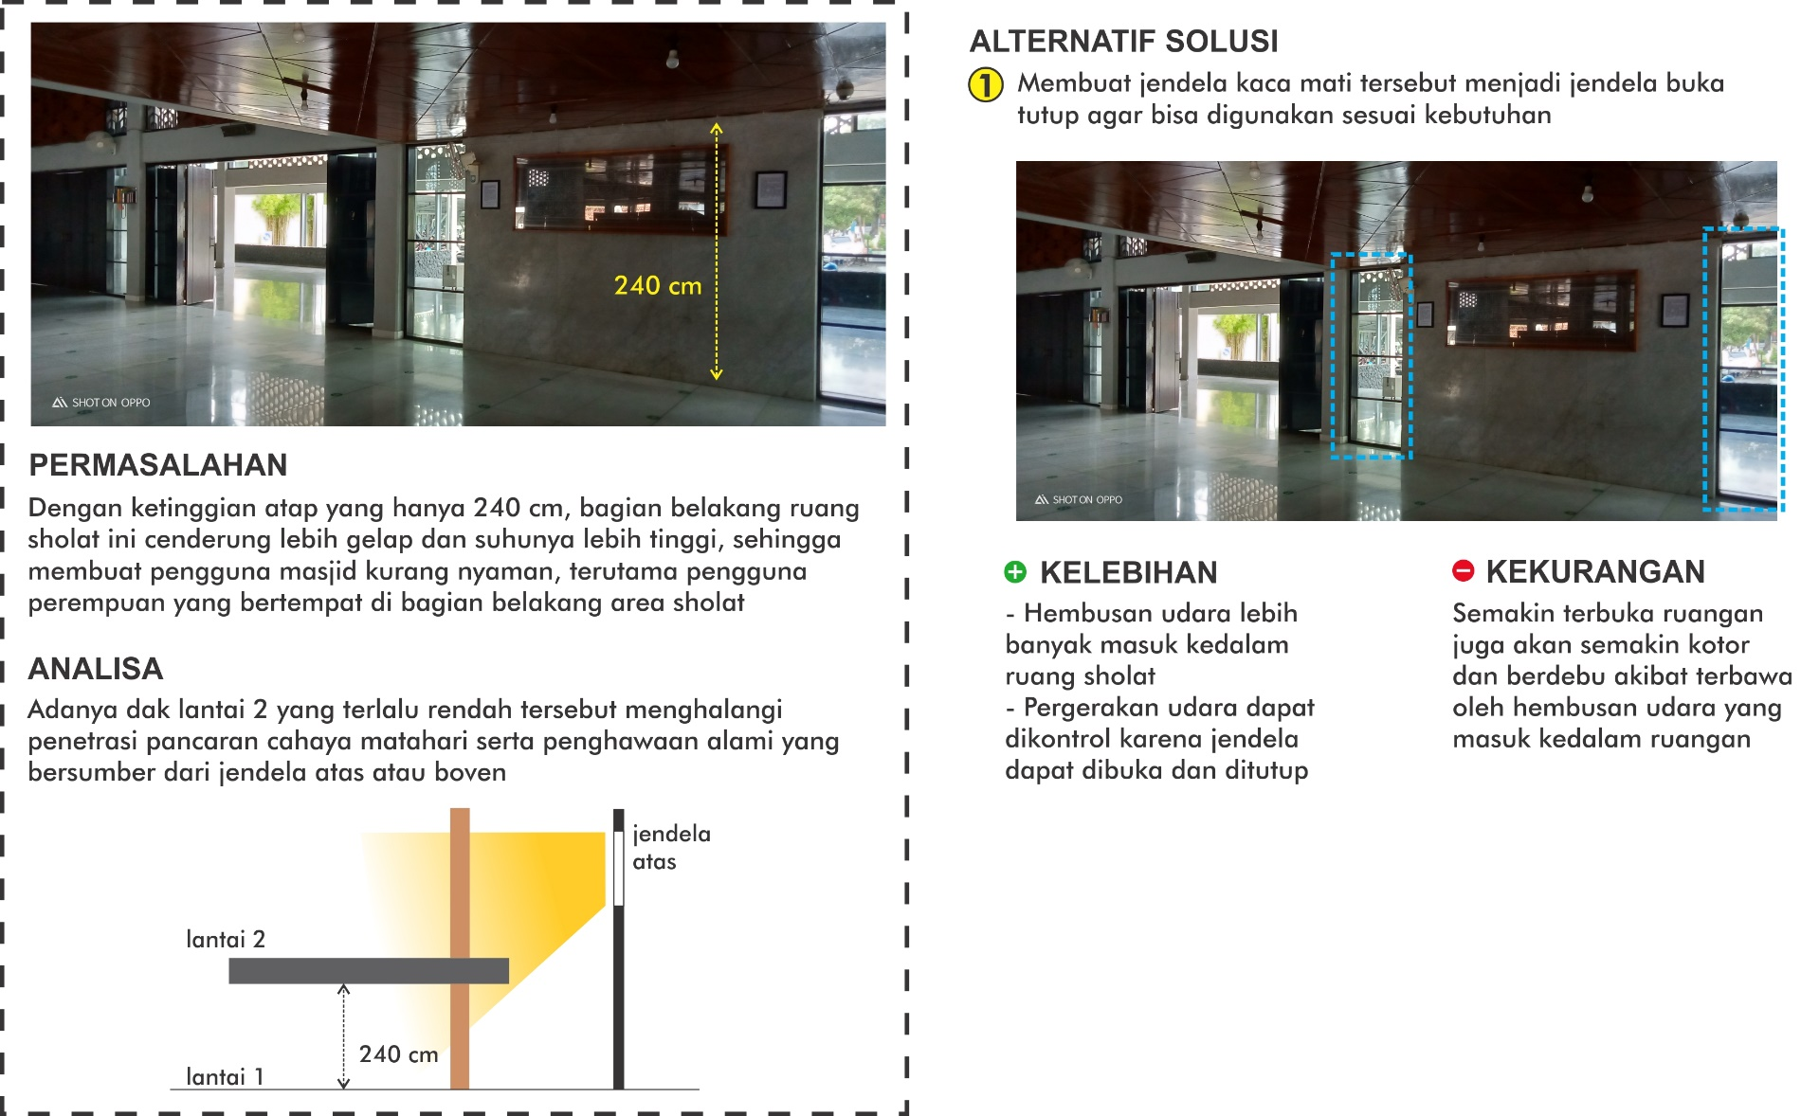
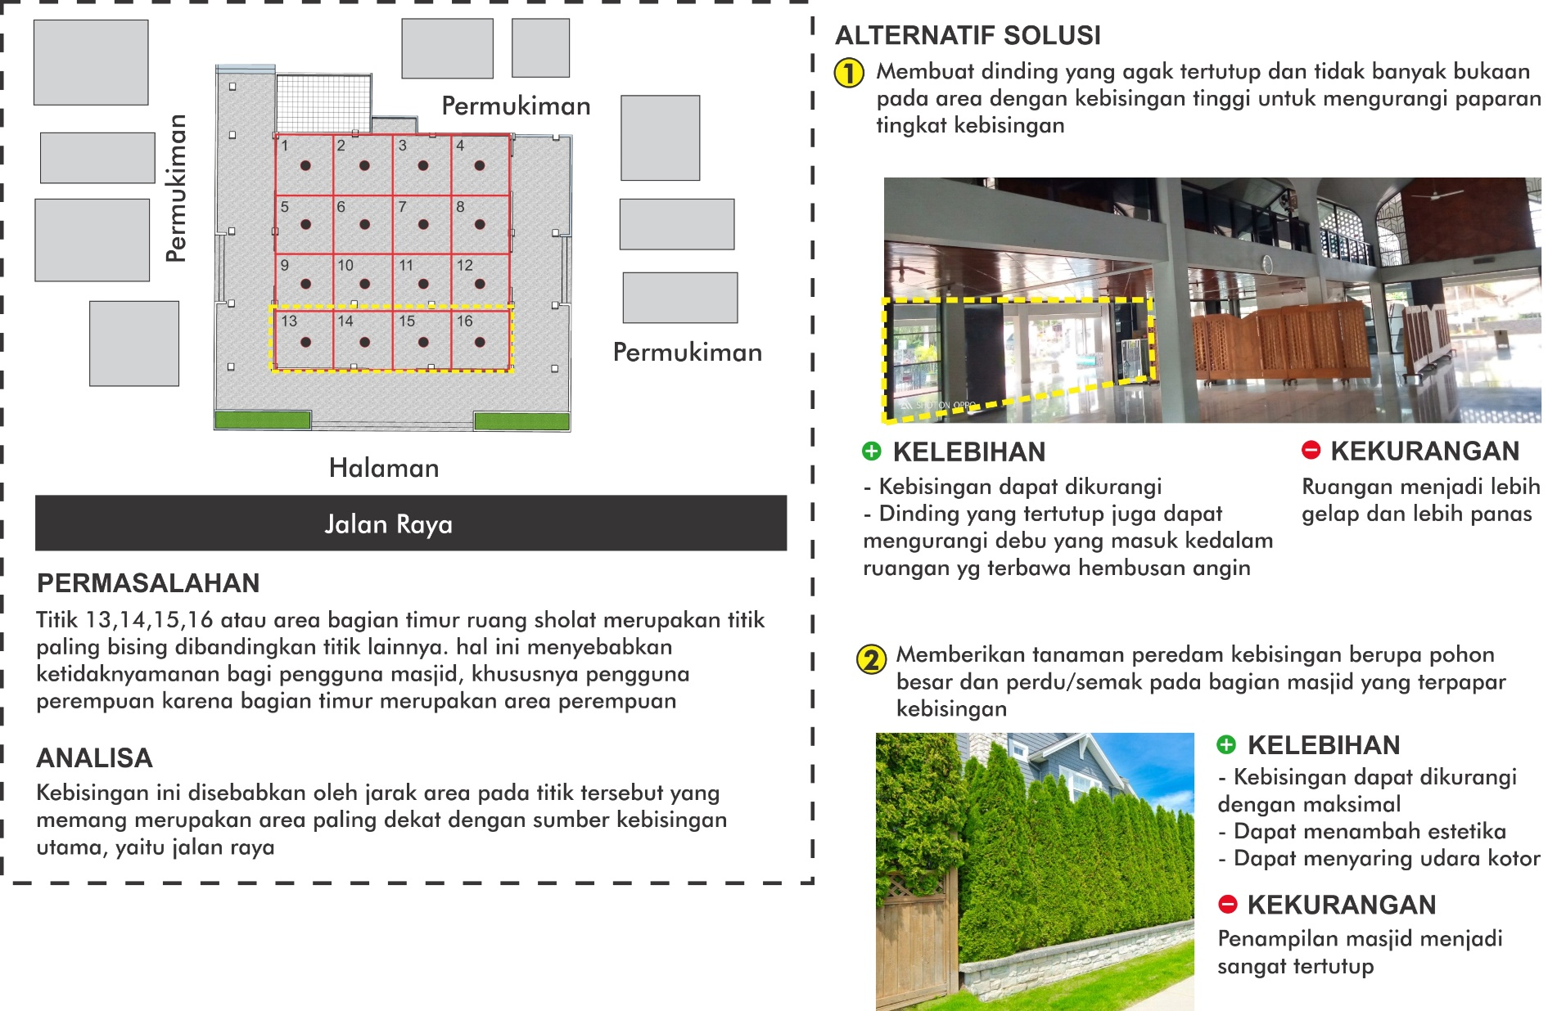
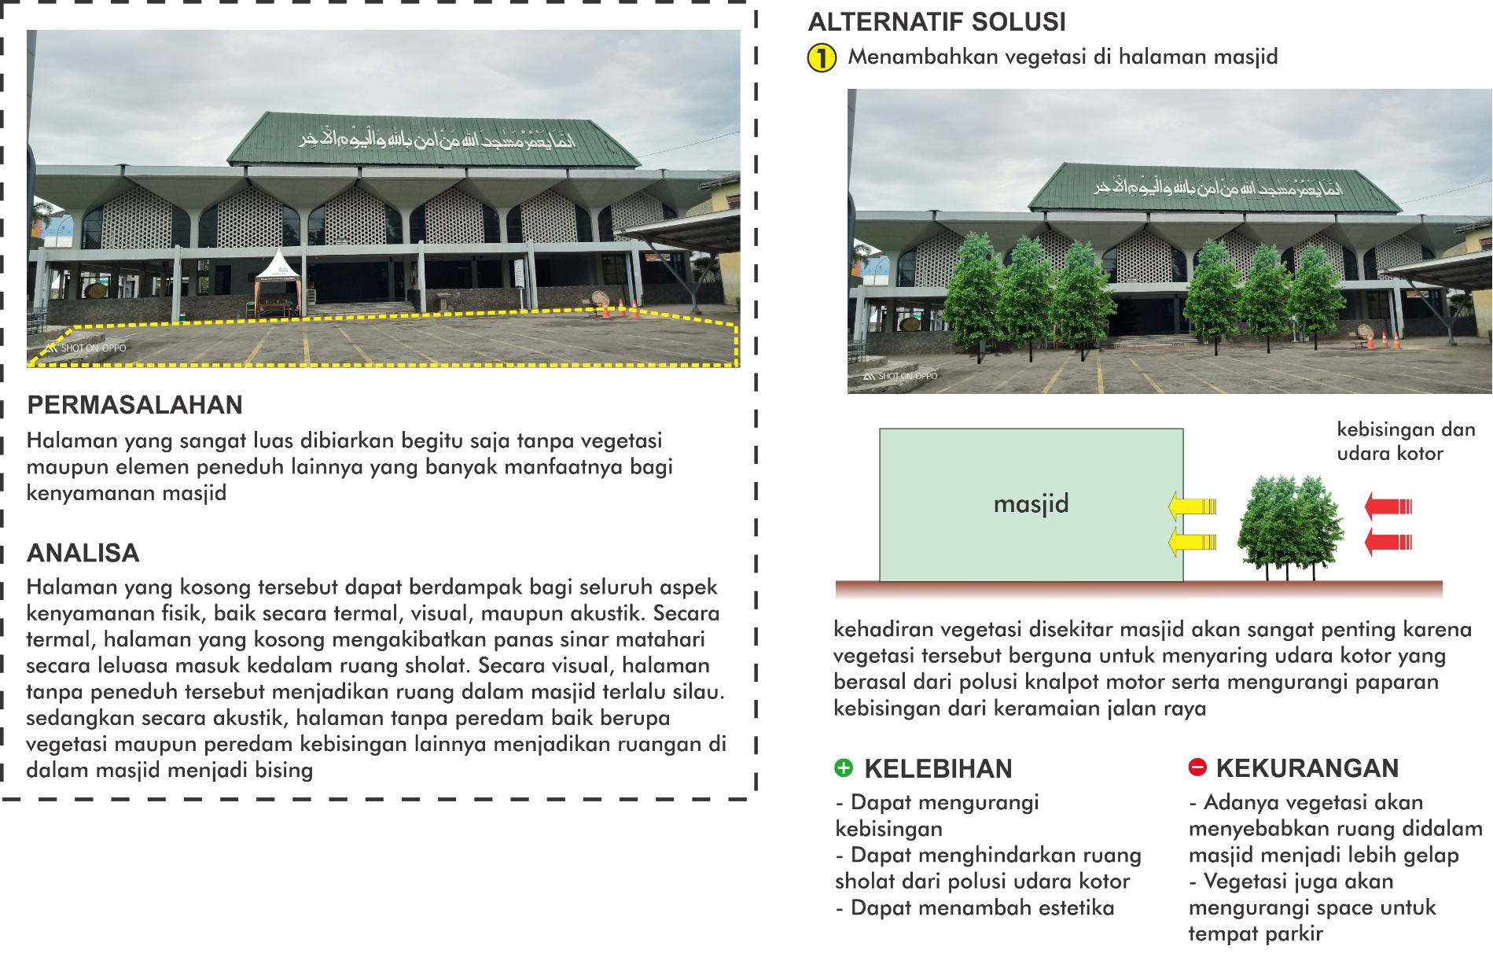
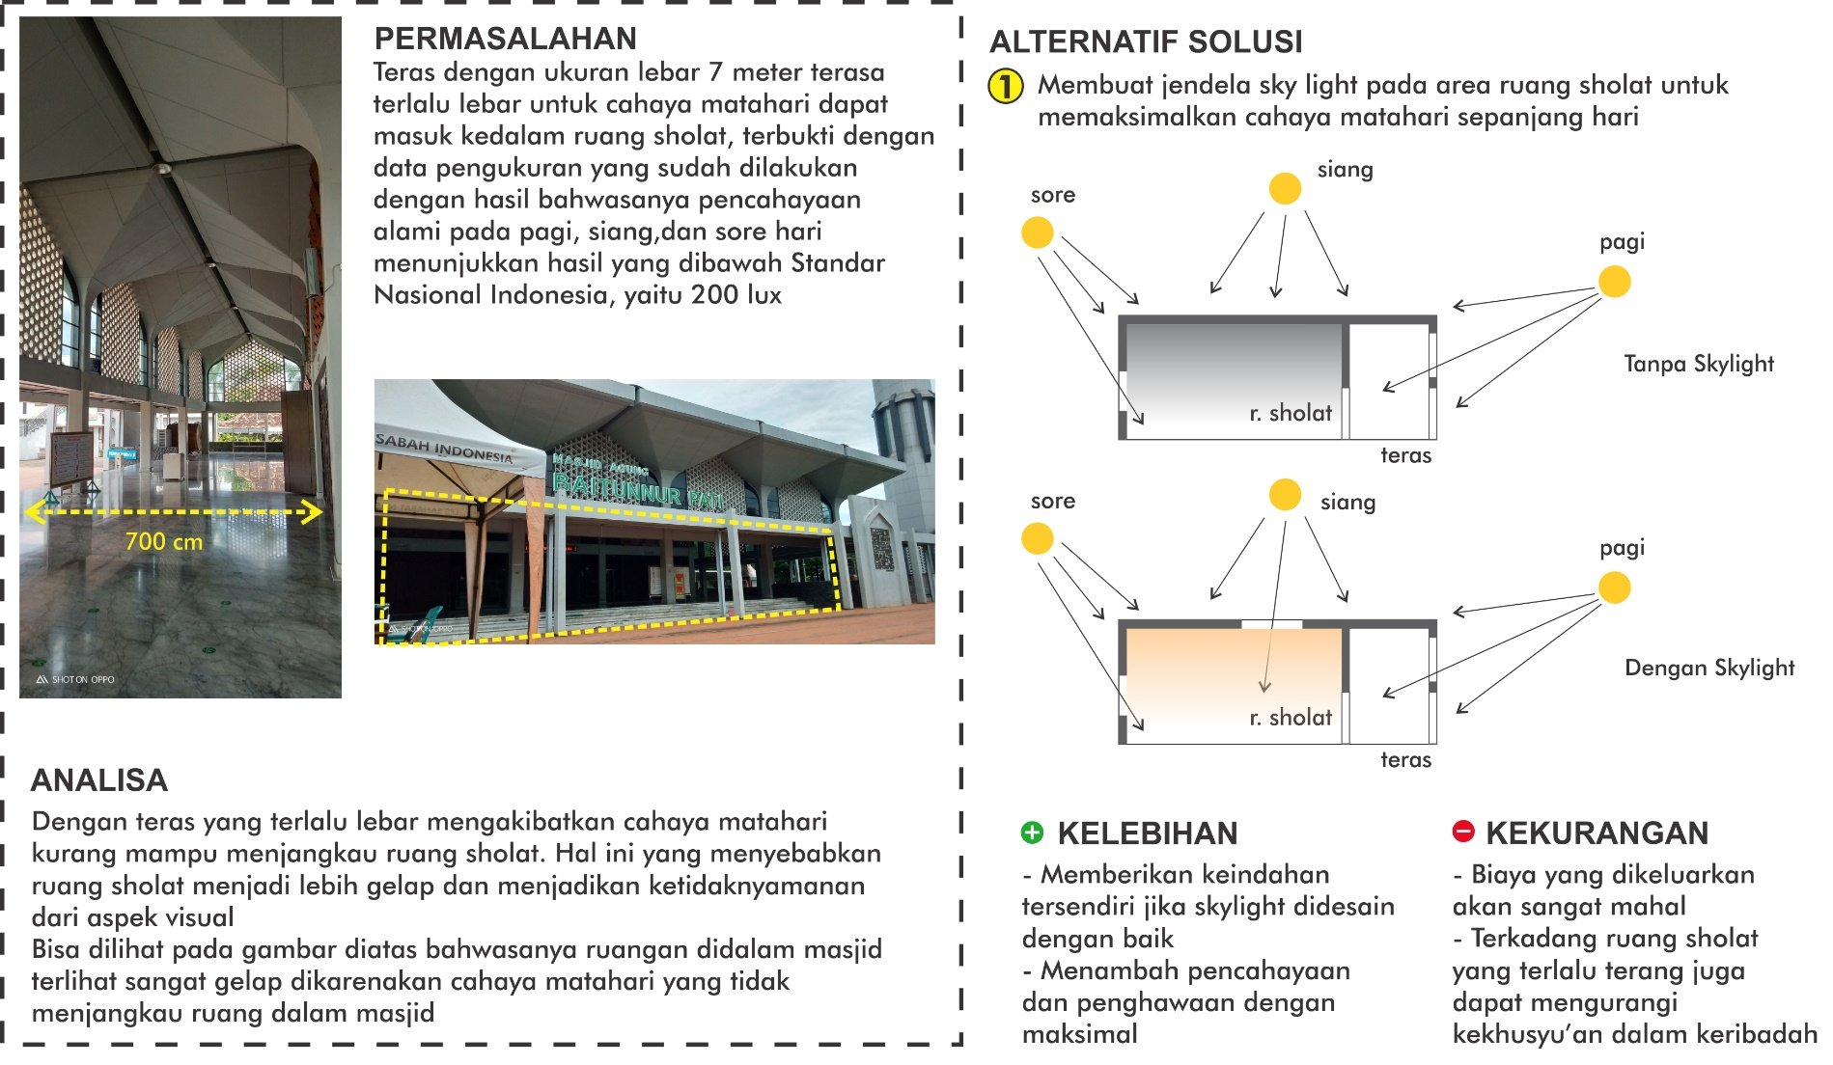

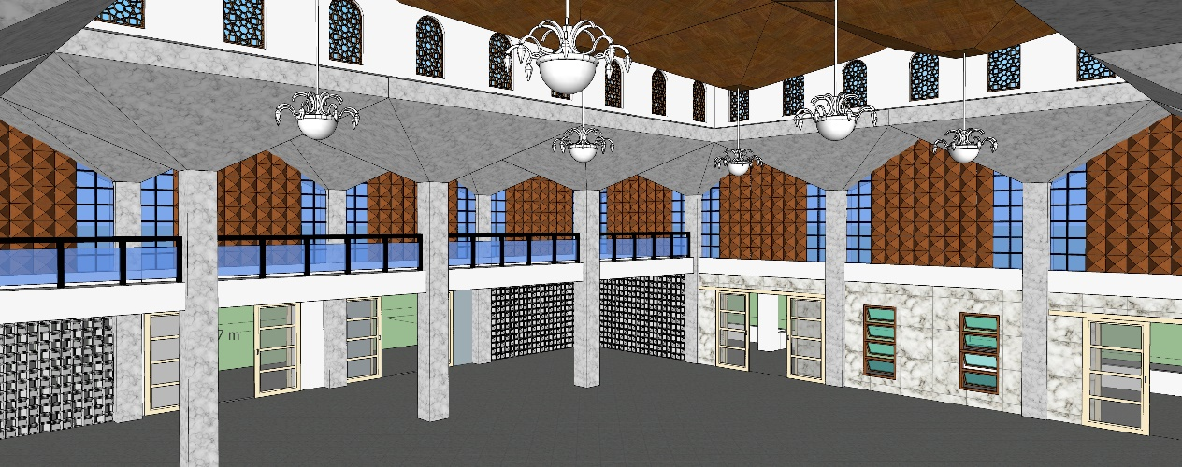
Galeri Hasil Redesain
