Butaro Hospital, a Sustainable Hospital with Participatory Design and Construction Process

Gunawan Tanuwidjaja¹, Ellen Yih-Jing Huang², Ilena Hadi Sutanto², Antonius Archie Tobias², Chen Ce Siong², Jesslyn Bahtiar², and Yohanes Richo Wirawan²

¹Architecture Program Study, Petra Christian University
² Students of Architecture Program Study, Petra Christian University
gunteitb2012@gmail.com

ABSTRACT

Healthcare facilities are very important for sustainable rural regions in developing countries. The Republic of Rwanda, in central east Africa, suffered massive social conflict in 1994 between the Hutu and Tutsi. Furthermore the health problem happened in Burera District because of lack of a proper district hospital. Therefore, in January 2011, the Rwandan Ministry of Health and Partners in Health (PIH) opened the 140-bed Butaro Hospital in the Burera District of Rwanda. The paper-based research was conducted based on hospital’s architecture of Hatmoko, et.al. (2010). Analysis was made with based on the secondary data of Butaro Hospital. Lastly, primary data gathering would be conducted if the funding allowed. The Butaro Hospital was an affordable solution for healthcare problems in rural regions of the developing countries, especially the infectious diseases (such as: HIV, malaria, tuberculosis, nose-ear-and-throat disease). Sustainable innovative solutions for minimum infection were implemented such as: external corridors, large-radius-low-speed fans (with diameters of 24 feet), high-louvered windows, germicidal UV lights, and non-permeable-continuous flooring. The construction of the hospital also would reduce the impact of political crisis in 1994. The project created 4,000 jobs for local craftsmen and local residents. They were initially trained for manual excavation, construction, and project management, before involving in the hospital construction. Therefore, the Butaro Hospital supported the smart regions of Burera area.

Keywords: Sustainable and affordable hospital, participatory design, local material.

ABSTRAK

Fasilitas kesehatan sangat penting bagi daerah-daerah pinggiran yang berkelanjutan di negara-negara berkembang. Republik Rwanda, negara di Afrika Tengah, mengalami konflik sosial pada tahun 1994 antara Hutu dan Tutsi. Masalah kesehatan timbul di Distrik Rwanda karena kurangnya rumah sakit yang layak. Karena itu, pada Januari 2011, Kementerian Kesehatan Rwanda bekerja sama dengan Partners in Health (PIH) membuka Rumah Sakit Butaro yang memiliki kapasitas 140 ranjang di Distrik Burera di Rwanda. Penelitian untuk makalah ini dibuat berdasarkan buku Arsitektur Rumah Sakit oleh Hatmoko, et.al. (2010). Analisis dibuat berdasarkan data sekunder Rumah Sakit Butaro dan akan dilanjutkan dengan pengumpulan data primer apabila tersedia dana yang dibutuhkan. Rumah Sakit Butaro adalah sebuah solusi yang terjangkau untuk masalah-masalah kesehatan di daerah-daerah terpencil pada negara-negara berkembang, terutama untuk mengatasi permasalah penyakit-penyakit menular seperti HIV, malaria, tuberculosis, dan penyakit telinga-hidung-tenggorokan. Solusi-solusi inovatif yang berkelanjutan untuk meminimalisasi infeksi diterapkan di rumah sakit ini, seperti koridor eksternal, large-radius-low-speed fans (dengan diameter 24 feet), jendela-jendela tinggi yang berkisi-kisi, lampu-lampu ultraviolet anti bakteri, dan implementasi non-permeable-continuous flooring.
Pembangunan Rumah Sakit Butaro juga telah mengurangi dampak dari krisis politik yang terjadi pada tahun 1994 dengan membuat 4.000 lapangan pekerjaan bagi pengrajin-pengrajin serta penduduk lokal. Pekerja-pekerja ini sebelumnya diberi pelatihan mengenai penggalian manual, konstruksi, dan manajemen proyek, sebelum dilibatkan secara langsung dalam pembangunan rumah sakit. Oleh karena itu, Rumah Sakit Burera telah berhasil mendukung perkembangan wilayah Burera.

Kata kunci: Rumah sakit yang berkelanjutan dan terjangkau, desain partisipatif, material lokal.

1. Introduction

Healthcare facilities are very important for sustainable cities and regions. Many rural regions in developing countries were underprivileged because of lack of healthcare services. The provision of healthcare facilities would answer the healthcare in the rural areas, increasing the survivor rate of patients. Furthermore, it could reduce the population pressure to the urban healthcare services.
The Republic of Rwanda is located in the central east Africa. The country is located in the humid sub-tropic climate and dominated by mountainous terrains, savanna, and lakes. The country suffered massive social conflict in 1994 between the Hutu and Tutsi, probably because of social castes and political difference. This caused the country economic and social deterioration (https://en.wikipedia.org/wiki/Rwanda).
Because of condition in January 2011, the Rwandan Ministry of Health and Partners in Health (PIH) opened the 140-bed Butaro Hospital in the Burera District of Rwanda. More than 340,000, living in District had very poor health indicators and was the poorest in the country. Before 2007, Burera was one of districts without a proper district hospital. Therefore, MASS Design Group was nominated to plan and design a proper health facility (http://www.archdaily.com/165892/butaro-hospital-mass-design-group/).
The design concept of the hospital was a more sophisticated holistic hospital model with appropriate technology and local community empowerment. The Butaro hospital could be categorized as secondary healthcare (general hospital). The hospital treated patients with infectious diseases (such as: HIV, malaria, tuberculosis, nose-ear-and-throat disease). Beside that, it also provided four health services such as: maternity, internal medicine, surgery, as well as pediatrics.

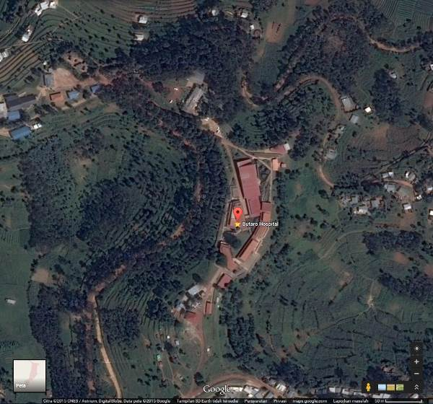

Figure 1. Siteplan of Butaro Hospital
(Source: www. google.com/maps/)

A literature study in Hatmoko, et.al. (2010) showed levels of healthcare services, such as: Hospital, Special Hospital and Clinic. The sustainable hospital also needed proper business plan, feasibility studies, vision, strategy, master plan and integrated building design. Several possible health services in the hospitals were: Emergency, Medical Records, ICU / ICCU, Nursing Unit, Rehabilitation Service, Trauma Center, Burn Unit, Urgent Care, Cancer Center, Post Anesthesia, Surgery Unit, Physical Therapy, Maternity, Outpatient (Ambulatory) Department, Inpatient Department, Radiology, Laboratory, and Laundry.
A sustainable hospital should be planned in several zones which are: the External zone (emergency, outpatient, and public administration services), Secondary Zone (laboratory, pharmacy and radiology), Inpatient zone (inpatient department), also the Internal zone (operation room, etc).
The hospital location selection is crucial. The sites should be safe from the landslide, flood, or not located on sensitive soil. It also should have excellent structural design and specification (flexibility and ductility) to be able to sustain from the natural disasters. Furthermore, physical characteristics of the hospital should be elegant, harmonious, accessible and environmentally friendly. On the other hand, hospitals design should be flexible for user changes and future development.
Specification of hospital’s interior should be designed based on infection risk zoning, such as: low risk, moderate risk, high risk and very high risk.
• The very high risk zone (such as: the operating room, dental care room, emergency room, delivery room, and pathologist room) should be designed cautiously. The walls specification should use ceramics or vinyl to the ceiling level. The ceiling should be constructed from strong material, secure, bright color, easy to clean, and reaching minimal height of 2.7 meter from the floor.
• The high risk zone (such as: isolation room, the intensive care unit, laboratory, medical imaging, autopsy, morgue) should be designed with flat surface and light-colored walls. Ceramic surface should be applied to 1.5 meter height. The ceilings of the zones should be designed from strong material, with bright colors, easy to clean, and reaching minimal height of 2.7 meter from the floor.
• The moderate risk zone (such as: outpatient care, dressing room, waiting room)
• The low risk zone (such as: administration room, office, meeting, library and training room). It should be designed with flat and light colored walls. The ceilings’ specification in the zone should be constructed with strong, bright colors, easy to clean, and reaching minimal height of 2.7 meter from the floor.
And the minimum doors’ sizes were 120 cm width and 210cm height. Lastly, window sill should be higher than 100cm from the floor. Air circulation was very important for thermal comfort, and infections control. Air filters should be provided for high and very high risk zone to prevent air-borne infections.
Daylighting had to be controlled by building orientation, shadings or corridors. Meanwhile, hospital’s man-made lighting also should be designed appropriately, not causing glares. Lastly, noise also should be overcome by interior design and acoustic materials application.

2. Methods

The research was conducted based on hospital’s architecture of Hatmoko, et.al. (2010). Furthermore, the Butaro Hospital in Rwanda was selected because of the importance of healthcare services in the rural areas in developing countries. Comparison was made between the literature and secondary data of Butaro Hospital, producing analyses. Lastly, primary data gathering would be conducted with the presentation of this paper in this particular seminar if the funding allowed.

2. Result and Discussions
The Butaro hospital was designed with facility of:

Table 1. The Butaro Hospital Facility

Facility of The Butaro Hospital in the First Floor | Facility of The Butaro Hospital in the Second Floor
A1.Ambulatory Unit  A2. Pharmacy  A3. Laboratories  A4. Paediatrics Ward  A5. Conference Room  A6. Staff Training  A7. Women’s Ward | B1. ICU  B2. Post Operative Ward  B3. Operating Room  B4. Check in  B5. Neonatal ICU  B6. Delivery Room  B7. Pre-Delivery Room  B8. Paediatrics Ward  B9. Post-Delivery Room  B10. Men’s Ward  B11. Laundry
Source: Author

The facility was divided into 4 zones such as:
• External Zone: Ambulatory Unit, Pharmacy;
• Secondary Zone: Laboratories, ICU, Post-Operative Ward;
• Inpatient Zone: Check in, Paediatrics Ward, Women’s Ward, Neonatal ICU, Delivery Room, Pre-Delivery Room, Paediatrics Ward, Post-Delivery Room, Men’s Ward;
• Internal Zone: Operating Room, Conference Room, Staff Training, Laundry.

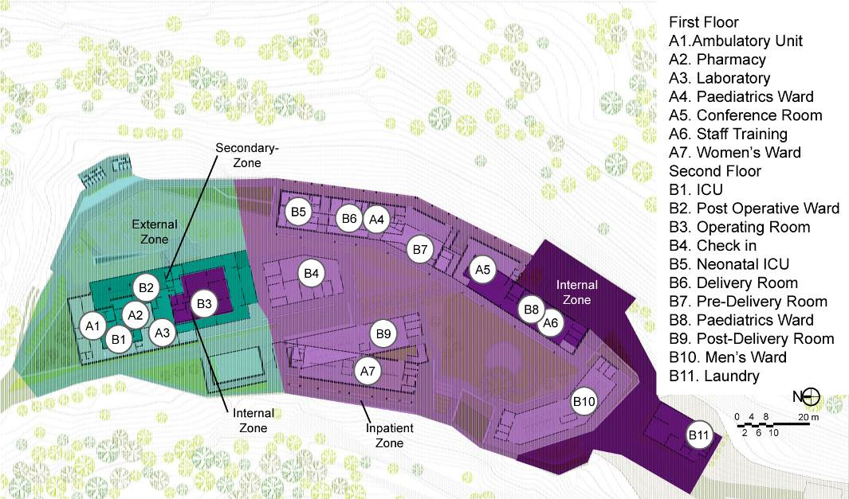

Figure 2. Zoning of Butaro Hospital
(Source: Analysis based on http://www.archdaily.com/165892/butaro-hospital-mass-design-group/)

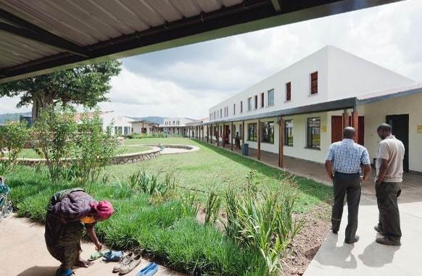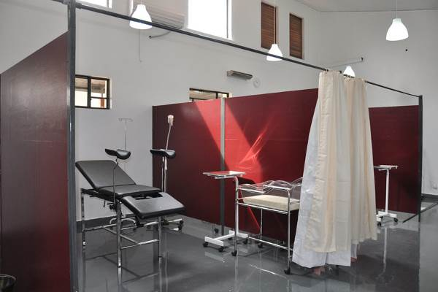

Figure 3. External Zone Butaro Hospital – Public Space & Outpatient (Ambulatory) Unit
(Source: http://www.pih.org/pages/butaro-hospital)

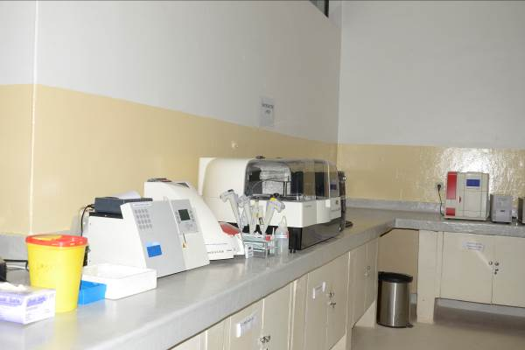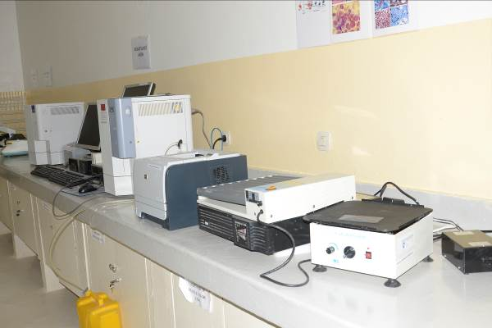

Figure 4. Secondary Zone Butaro Hospital – Laboratory
(Source: http://www.designboom.com)
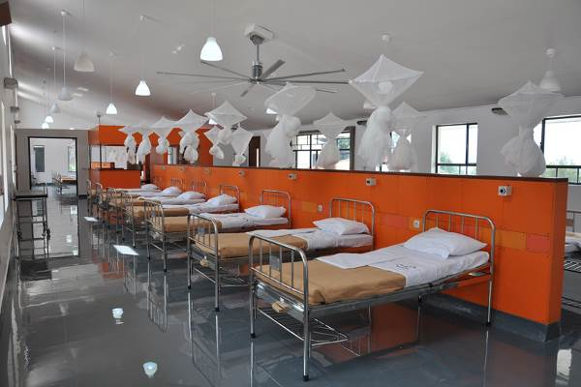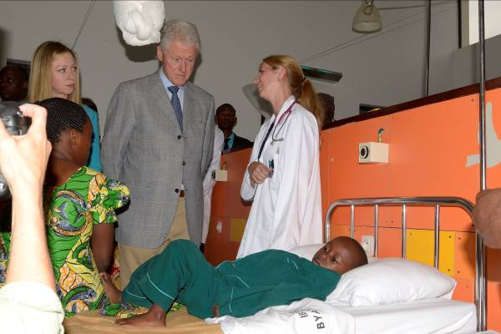

Figure 5. Inpatient Zone Butaro Hospital – Ward
(Source: http://www.designboom.com)

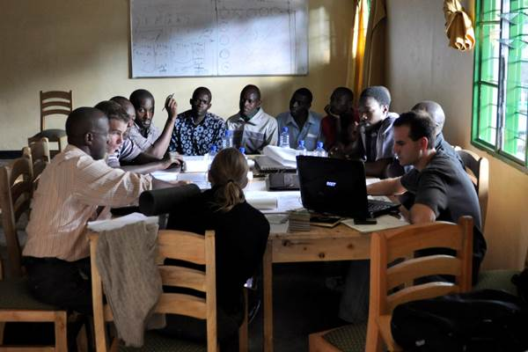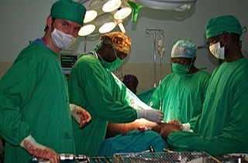

Figure 6. Internal Zone Butaro Hospital – Conference Room & Operation Room
(Source: http://www.designboom.com)

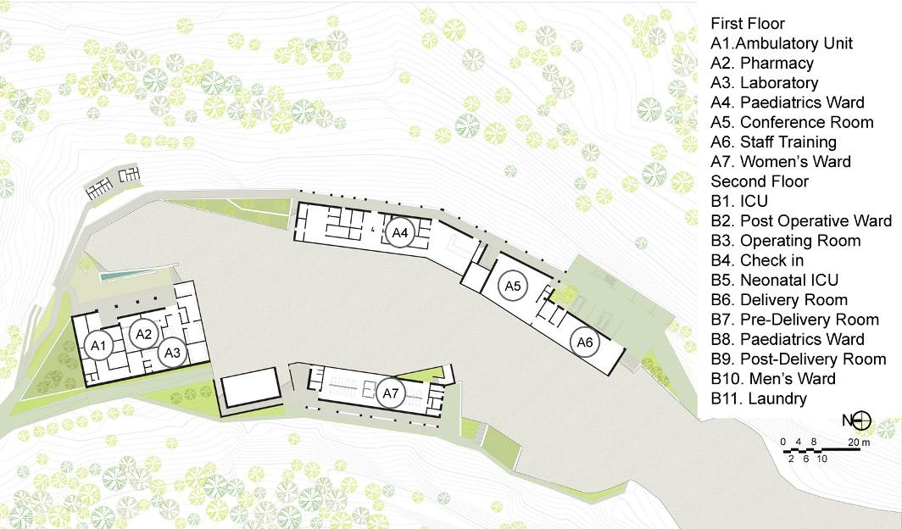

Figure 7. First Floor Plan of Butaro Hospital
(Source: http://www.archdaily.com/165892/butaro-hospital-mass-design-group/)

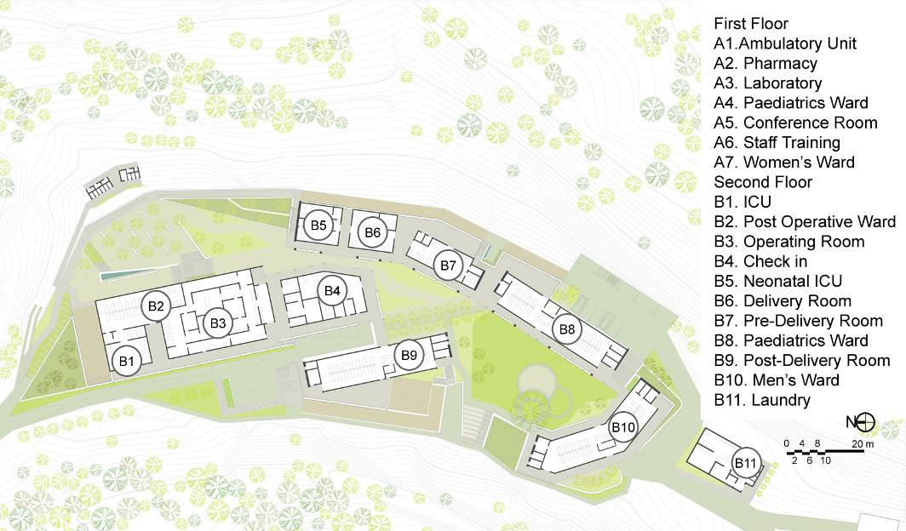

Figure 8. Second Floor Plan of Butaro Hospital
(Source: http://www.archdaily.com/165892/butaro-hospital-mass-design-group/)

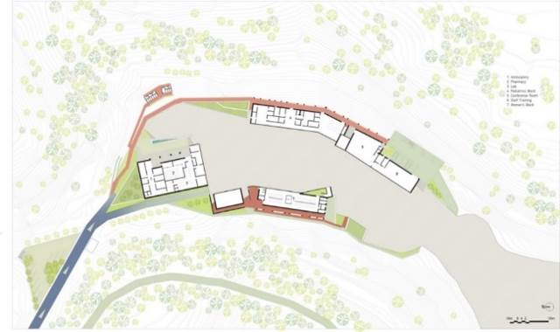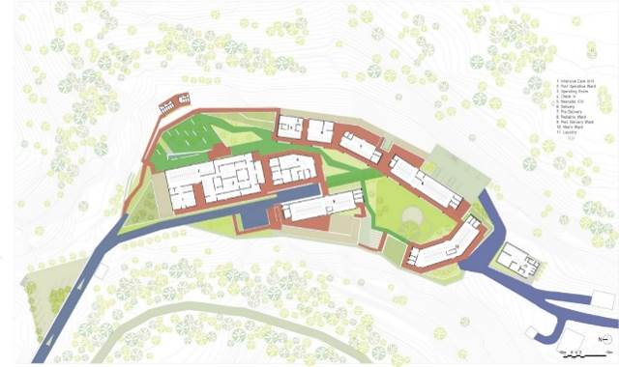

Figure 9. Circulation of Butaro Hospital
(Source: http://www.archdaily.com/165892/butaro-hospital-mass-design-group/)

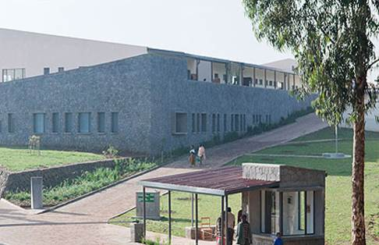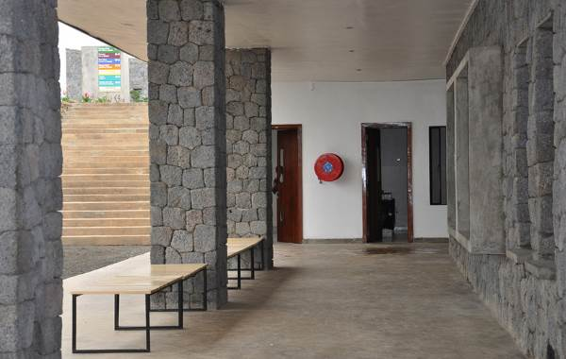

Figure 10. Ramps and Corridor for Circulation in Butaro Hospital
(Source: http://www.archdaily.com/165892/butaro-hospital-mass-design-group/)

The Butaro hospital design concept was to mitigate and reduce the transmission of airborne disease through several strategies, such as: overall layout, patient and staff flow, and natural ventilation. This would provide a good example for approach in remote areas of high risk for TB and other airborne diseases (http://www.archdaily.com/165892/butaro-hospital-mass-design-group/).
The Butaro Hospital applied innovative solutions for minimum infection. Corridors were designed in the perimeter of the buildings instead of internal corridors. Furthermore, large-radius-low-speed fans (with diameters of 24 feet) and louvered windows were installed to facilitate frequent air exchange. Germicidal UV lights were installed to kill or inactivate microbes when the air entered the upper louvered windows. The use of a non-permeable, continuous floor finish was implemented to fight bacterial growth. The floor type is easy to clean, durable, and safe by resisting infection (http://www.archdaily.com/165892/butaro-hospital-mass-design-group/).

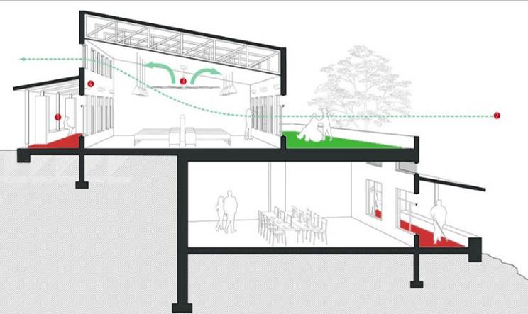

Figure 11. Sectional Perspective introducing the ventilation, while reducing airborne contamination
(Source: http://www.archdaily.com/165892/butaro-hospital-mass-design-group/)

The Butaro Hospital was designed and constructed involving grassroots business and development. The hospital was constructed with 100% local labor, (3,898 persons). They were initially trained for excavation, construction, and project management. The labors were divided into six teams, each working for two-week shift. All labors were provided with food, water, and healthcare. The construction was using labor instead of heavy equipment to create job and more community involvement (http://www.archdaily.com/165892/butaro-hospital-mass-design-group/). All the strategies were coherent with Hatmoko, et.al. (2010) and further would create a sustainable hospital.
The structural system of the hospital was the column and beam, also retaining walls. The materials used were locally available and affordable such as: concrete, wood, masonry, natural stone (volcanic stone) and steel. The masonry technique was easily found in the local craftsmen. The stone was abundantly available in northern Rwandan landscape. The stones were largely used for foundations, courtyard walls, in combination with mortar. Less mortar was applied to reveal the exceptionally unique and beautiful textures of the stones. The workshops and gradual constructions created more and more refined walls.

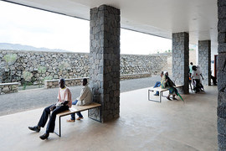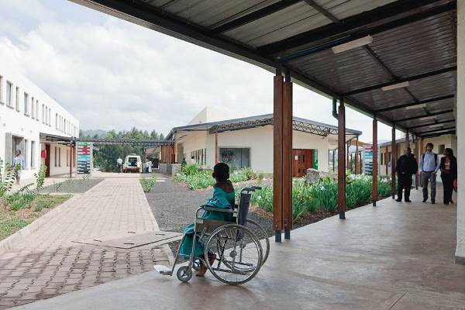

Figure 12. The Column and Beam structure of Butaro Hospital.
(Source: http://www.pih.org/blog/local-hands-and-hammers-forge-world-class-facility/ and http://www.contractdesign.com/contract/design/features/The-Power-of-Design-6243.shtml)

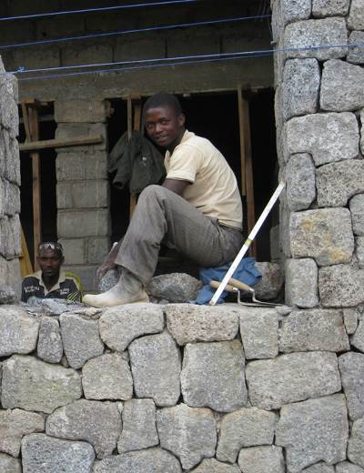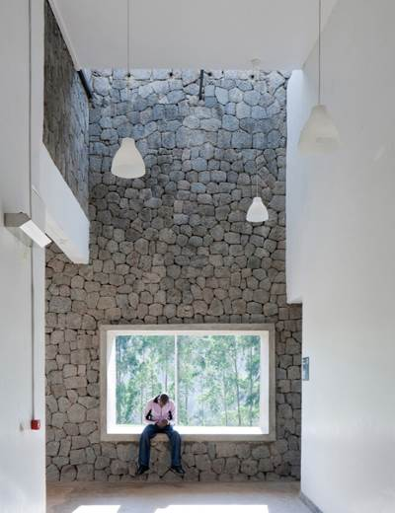

Figure 13. The Volcanic-Stone-Retaining Wall of Butaro Hospital.
(Source: http://www.pih.org/blog/local-hands-and-hammers-forge-world-class-facility/ and http://www.contractdesign.com/contract/design/features/The-Power-of-Design-6243.shtml)

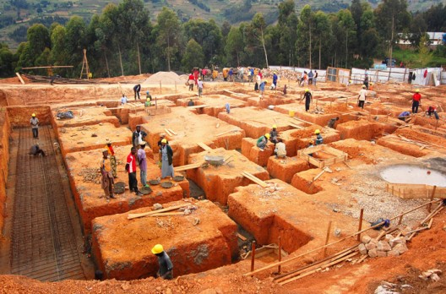

Figure 14. The Manual-Excavation process of Butaro Hospital.
(Source: http://www.pih.org/blog/local-hands-and-hammers-forge-world-class-facility/ and http://www.contractdesign.com/contract/design/features/The-Power-of-Design-6243.shtml)

The Butaro Hospital actually created an affordable health services, with pleasant atmosphere for community. The hospital was designed in harmony with surrounding rural areas because of participatory design process. It was also intended with attention to human scale, providing comfortable social space and healing gardens. The hospital’s interior design was designed with interesting wall colors and artwork supporting the healing process.

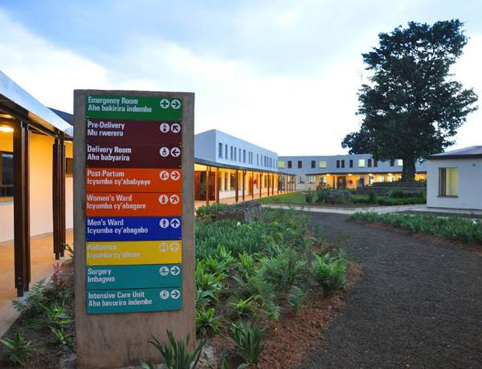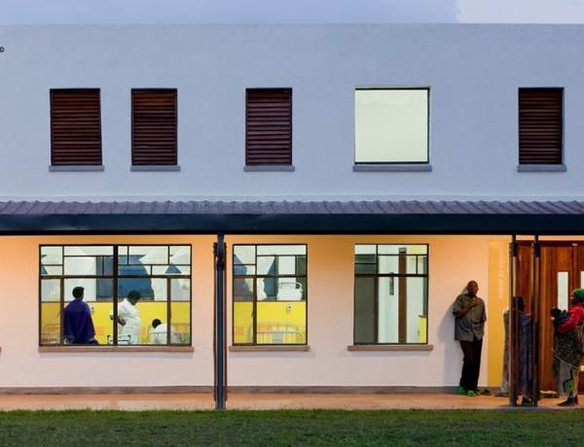

Figure 15. The Facade of Butaro Hospital
(Source: http://www.archdaily.com/165892/butaro-hospital-mass-design-group/)

2. Conclusions

The Butaro Hospital was an affordable solution for healthcare problems in rural regions of the developing countries, especially the infectious diseases (such as: HIV, malaria, tuberculosis, nose-ear-and-throat disease). Sustainable innovative solutions for minimum infection were implemented such as: external corridors, large-radius-low-speed fans (with diameters of 24 feet), high-louvered windows, germicidal UV lights, and non-permeable-continuous flooring.
The construction of the hospital also would reduce the impact of political crisis in 1994. The project created 4,000 jobs for local craftsmen and local residents. They were initially trained for manual excavation, construction, and project management, before involving in the hospital construction. Therefore, the Butaro Hospital created a sustainable healthcare services, which further support the smart regions of Burera area.

Acknowledgements
Acknowledgements are awarded to:
- Dean of the Faculty of Civil Engineering and Planning, Petra Christian University, Mr. Timoticin Kwanda, B.Sc., MRP., Ph.D.
- Architecture Program Study Chairman, Petra Christian University, Mrs. Eunike Kristi Julistiono, ST, M.Des.Sc.
- Students of Introduction to Healthcare Design, Petra Christian University, Architecture Program Study, in 2014-2015.

References

Hatmoko, A., U., Wulandari, W., Alhamdani, M., R. (2010). Arsitektur Rumah Sakit (in English Hospital Architecture). Yogyakarta: Global Rancang Selaras.
http://www.archdaily.com/165892/butaro-hospital-mass-design-group/
http://www.contractdesign.com/contract/design/features/The-Power-of-Design-6243.shtml
http://www.designboom.com
http://www.pih.org/blog/local-hands-and-hammers-forge-world-class-facility/
http://www.pih.org/pages/butaro-hospital
https://en.wikipedia.org/wiki/Rwanda

